|  |  |
| --- | --- |
|  |  |

**PROBLEM STATEMENT:**

Implementation of heating and mixing of two products using scada software. Material A of tank 1 and material B of tank 2 should be mixed and heated till it reaches its set point with the help of scada software.

**PROBLEM SOLUTION:**

* Material A will be inside tank 1 and material B will be inside tank 2.
* First material A will be poured inside tank 3 and after that material B will be poured inside tank 3.
* As soon as the tank 3 will be full of material A and material B mixing and heating process will start.
* Motor will start mixing the products and heater will heat the product.
* After the heating and mixing process the product will come out of the tank 3 with the help of outlet valve.

**PROBLEM DIAGRAM:**

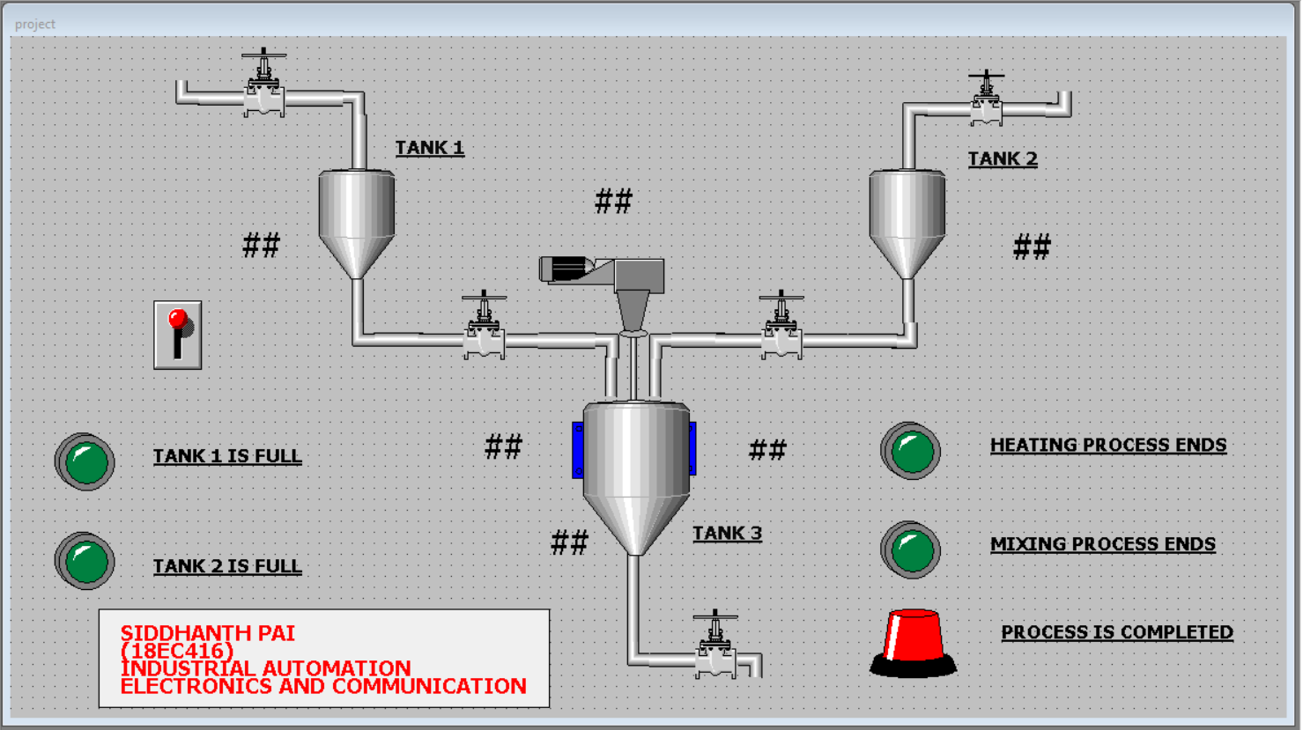

**PROBLEM DESCRIPTION:**

* As the start button will be pressed the tank 1 will start filling with the product A and as the tank 1 will be full the light indicator will be turn ON indicating that the tank 1 is full.
* Now the tank 2 will start filling with the product B and as soon as tank 2 will be full the light indicator 2 will turn ON indicating that the tank 2 is full.
* Then the product A from tank 1 will be poured inside the tank 3 and the light indicator 1 will be turn OFF.
* As soon as the tank 3 will be filled with product A, the product B from the tank 2 will be poured inside tank 3 and light indicator 2 will be turned OFF.
* Now the heating process will take place for a particular time period and then the mixing of the product with the of mixer will takes place for a particular time.
* As the heating and mixing process will end the respective light indicators of heater and mixer will be turned ON.
* After mixing and heating the product will come out of the tank will the help if the outlet valve and the light indicator will be turned ON indicating that the whole process is been done successfully.

**SCREENSHOTS ARE LISTED BELOW:**

1. Windows script (ON SHOW).
2. Windows script (WHILE SHOW).
3. Configurations of valve 1.
4. Configurations of valve 2.
5. Configurations of valve 3.
6. Configurations of valve 4.
7. Configurations of valve 5.
8. Configurations of tank 1.
9. Configurations of tank 2.
10. Configurations of tank 3.
11. Configurations of heater.
12. Configurations of motor.
13. Configurations of light 1.
14. Configurations of light 2.
15. Configurations of light 3.
16. Configurations of light 4.
17. Configurations of light 5.

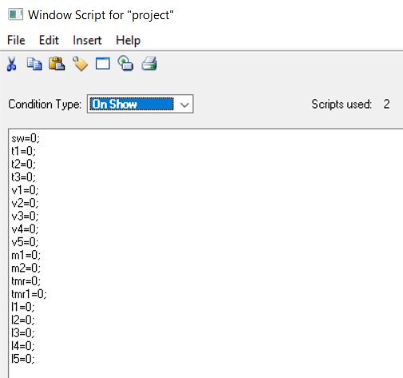

**1.** **Windows script (ON SHOW).**

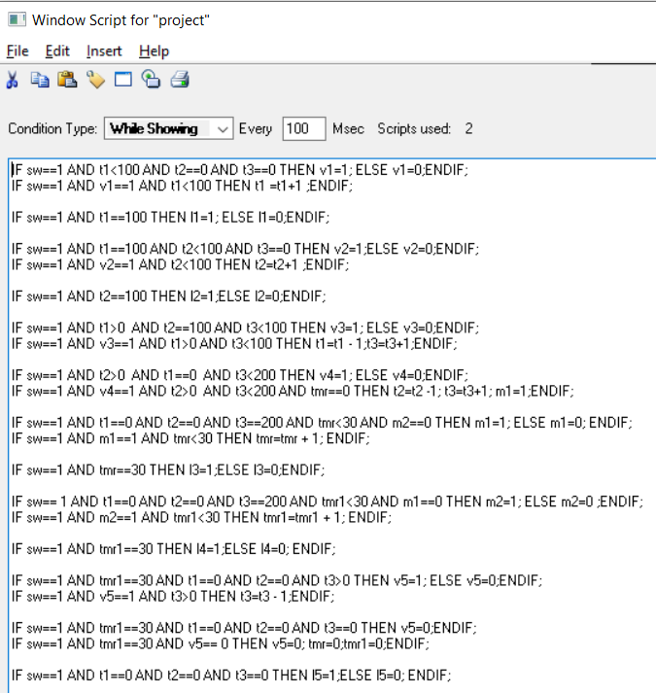

1. **Windows script (WHILE SHOW).**

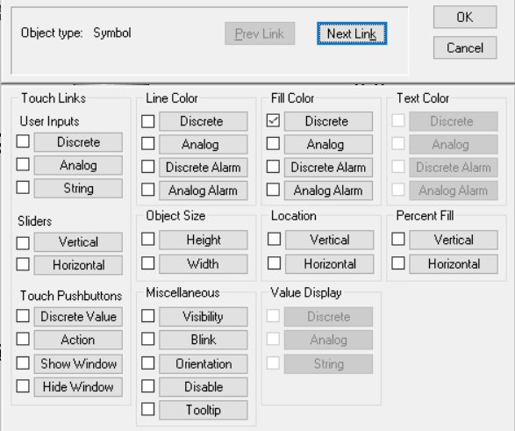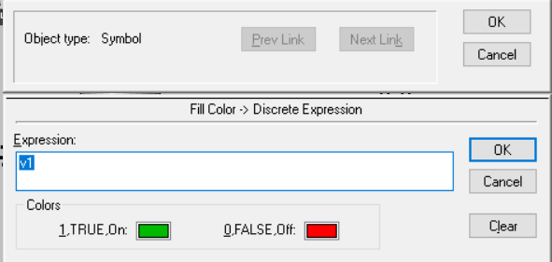

1. **Configurations of valve 1.**

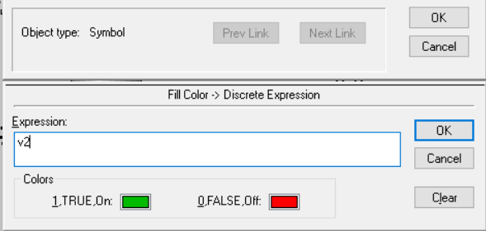

1. **Configurations of valve 2.**

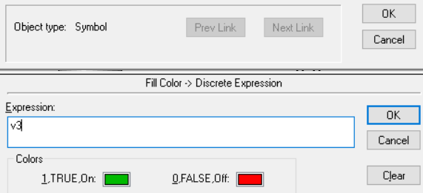

1. **Configurations of valve 3.**

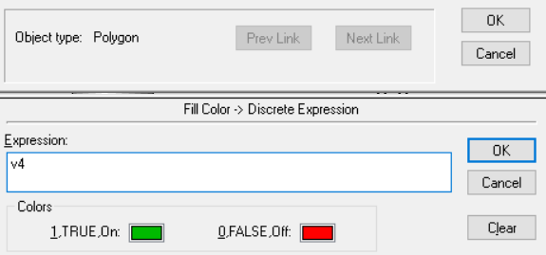

1. **Configurations of valve 4.**

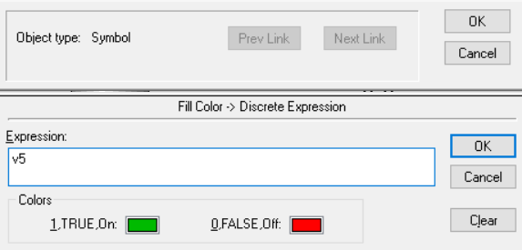

1. **Configurations of valve 5.**

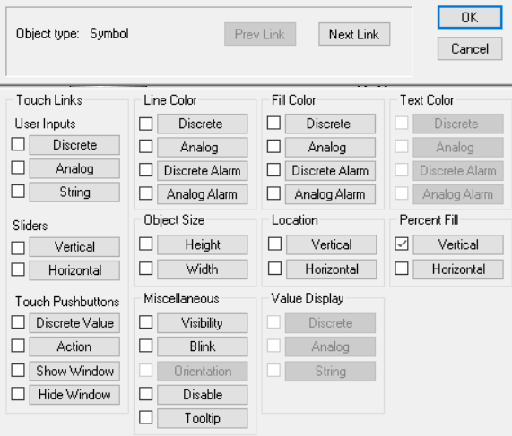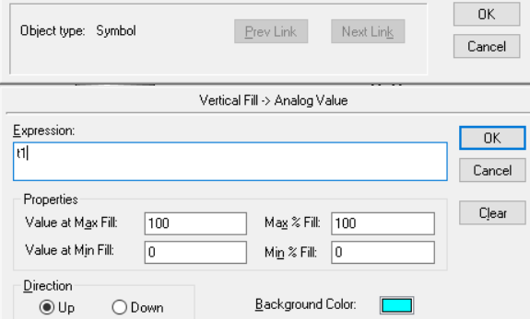

1. **Configurations of tank 1.**

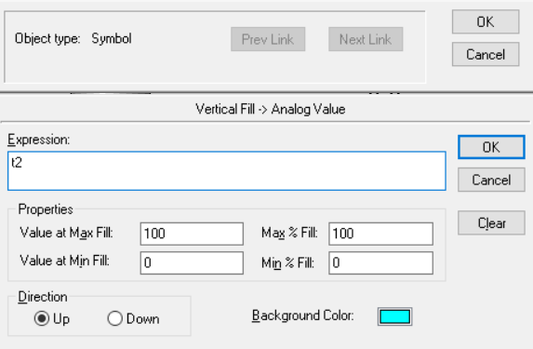

1. **Configurations of tank 2.**

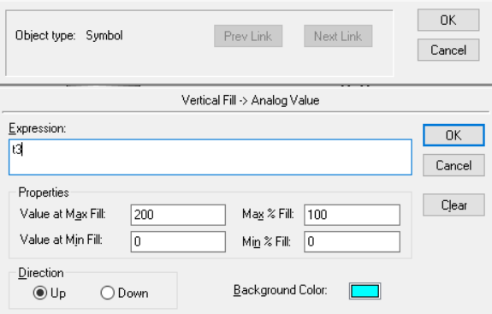

1. **Configurations of tank 3.**

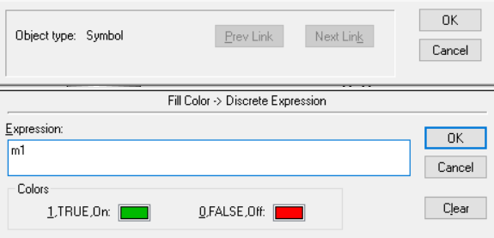

11. **Configurations of heater.**

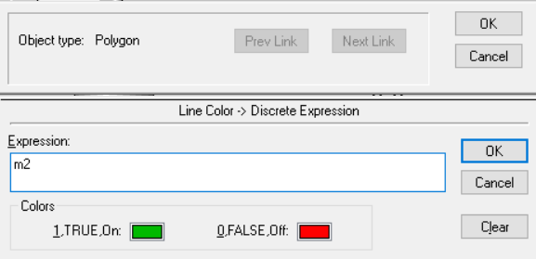

1. **Configurations of motor.**

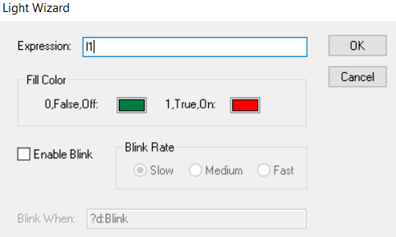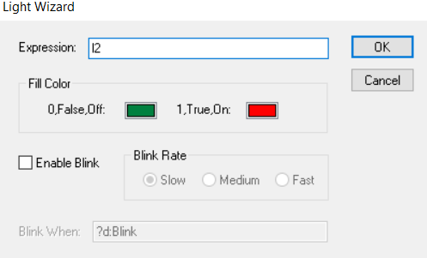

1. **Configurations of light 1.** 14. **Configurations of light 2.**

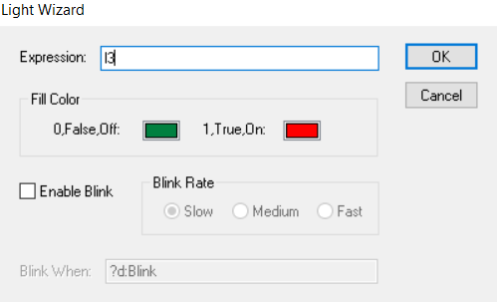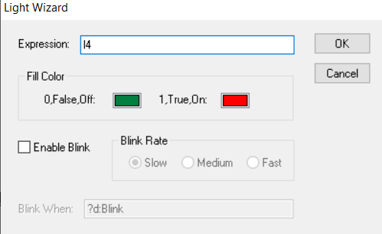

**15.Configurations of light 3. 16. Configurations of light 4.**

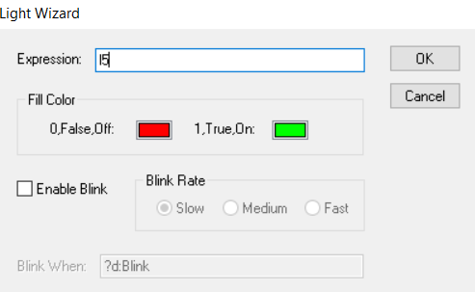

1. **Configurations of light 5. Link to excess video**